TEACHING AID

Datak
TEACHING INFORMATION
Equipment needed:
Computers, tablets or smartphones
Internet connection

Levels:
End of lower secondary, and upper secondary

Number of lessons:
4 to 5 if the class carries out the proposed extensions

This sheet and additional content are available at:
datak.rts.ch/ecoles
Contact: datak@rts.ch
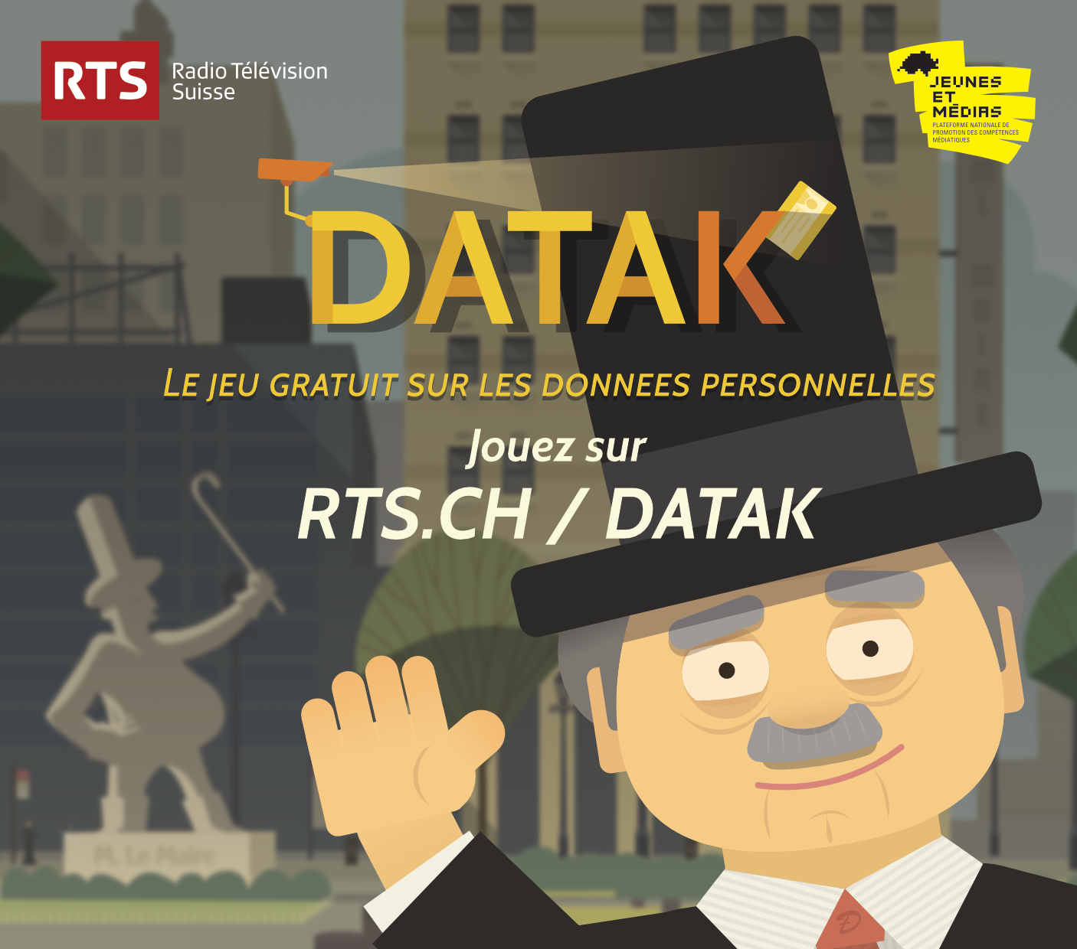
www.rts.ch/datak

THE GAME THAT HELPS YOU GET TO GRIPS WITH YOUR PERSONAL DATA

INTRODUCTION

From loyalty cards and medical records to geolocation and biometric passports, our personal data is collected and used on a huge scale. But by whom and for what purpose? Under the auspices of On en parle, a major interactive investigation was conducted (www.rts.ch/mesdonnees) on the RTS channels and social media Facebook and Twitter (#mesdonnees) between 9 June 2015 and 13 December 2016.

“This sheet is a translation from the original version in French. The game DATAK is available in 4 languages, but the extra content mentioned in the present sheet only exists in French. Hence, some of the activities will require prior content research in your own language.”

Datak – the serious game

Datak is the culmination of this investigation. The game invites players aged 15 or over to assume the role of a trainee assistant data protection manager in the town of DataVille. Players are faced with various daily dilemmas and specific questions from DataVille’s mayor, such as whether to approve a project to install CCTV cameras in the town and whether to pass on citizens’ data to companies or political parties. Every decision has an impact on the organisation of the community, the player’s progress in the game and the trainee’s private life. Players have to comply with certain constraints - a daily allotted time, a tight budget, a low salary… The challenge is for players to fulfil their mission in seven days.

Datak is available in 4 languages: English, French, German and Italian
“The aim is to provide an educational tool in four languages, but more importantly a fun and informative game that raises awareness without lecturing” – Julien Schekter, producer of the programme On en Parle

Objectives of the game
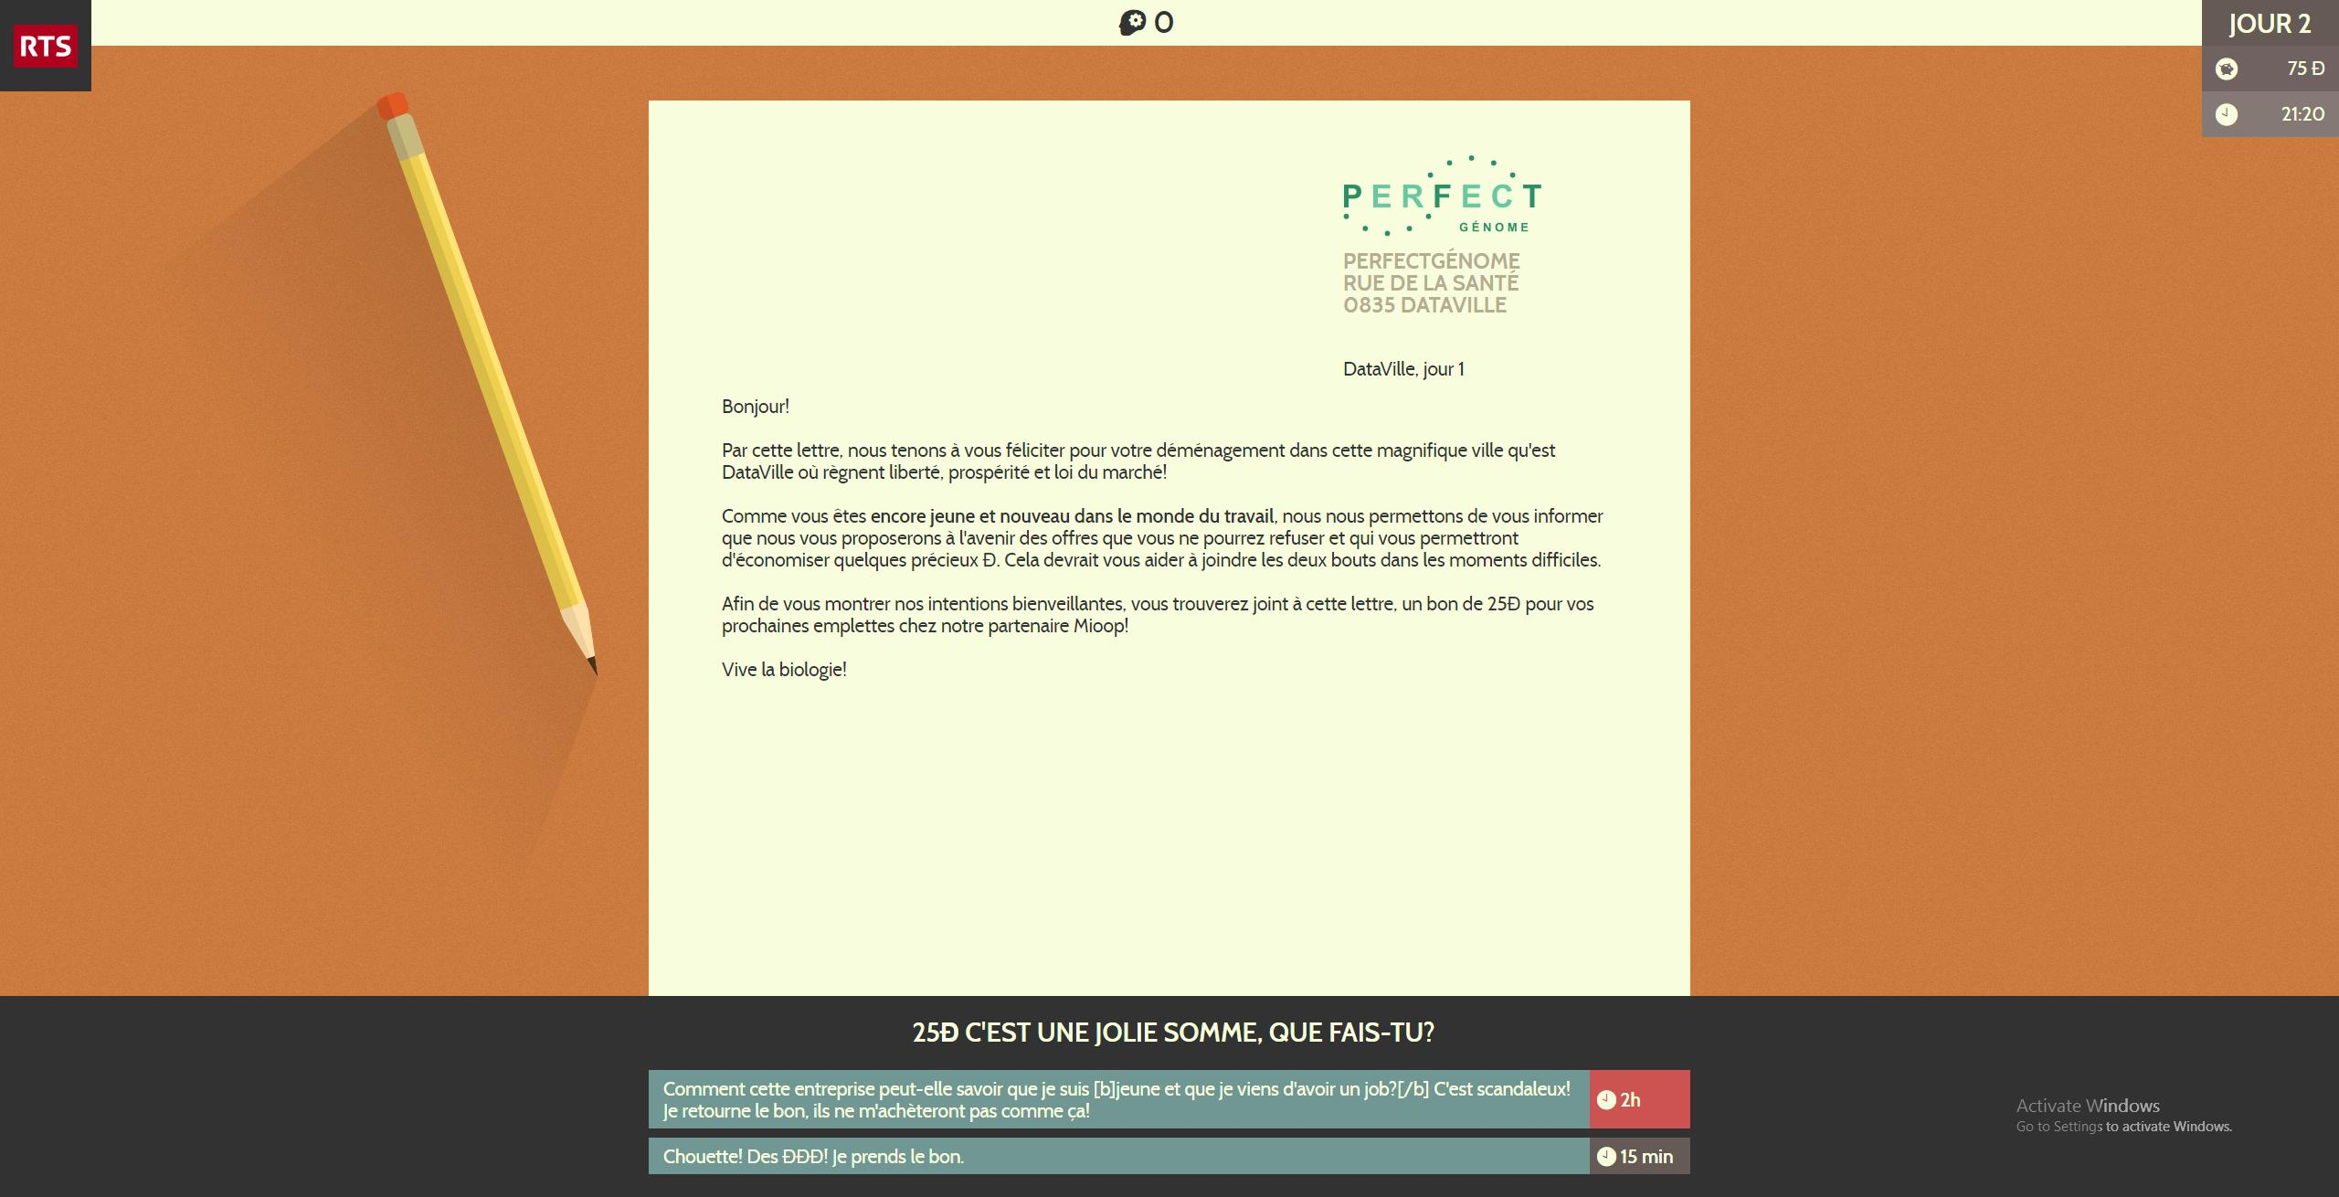

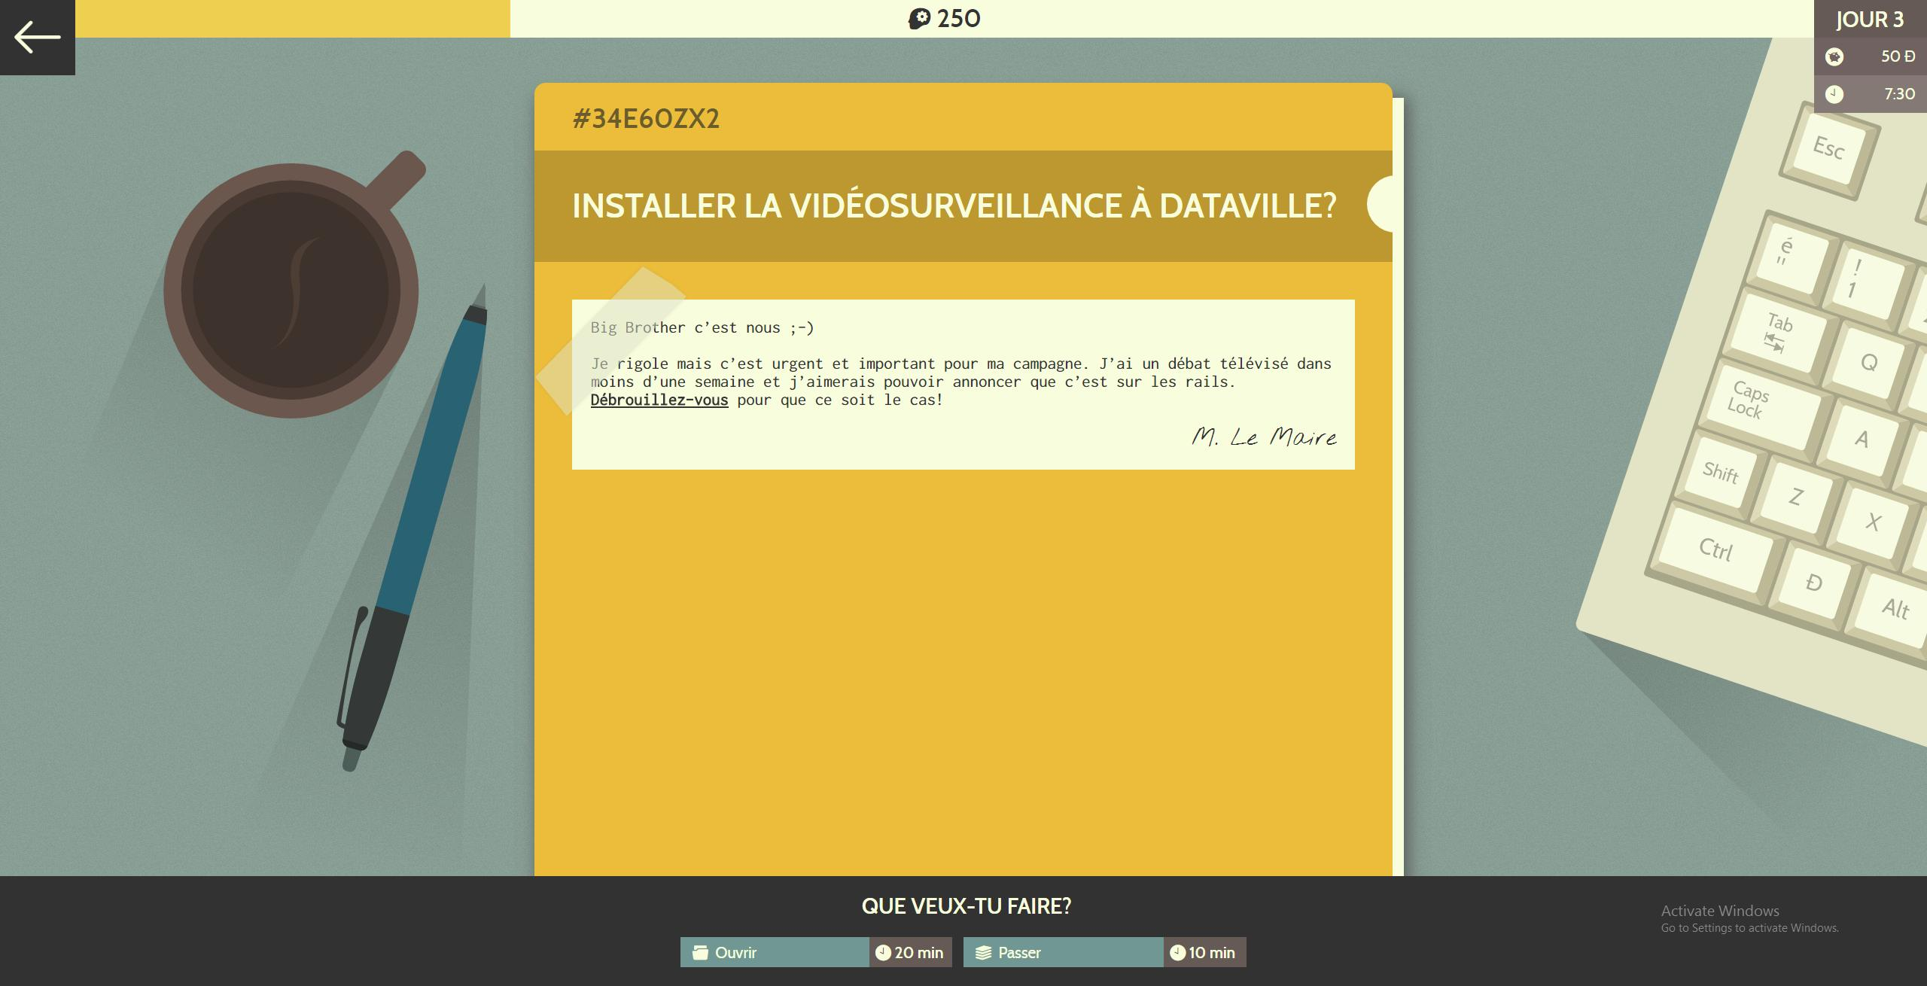

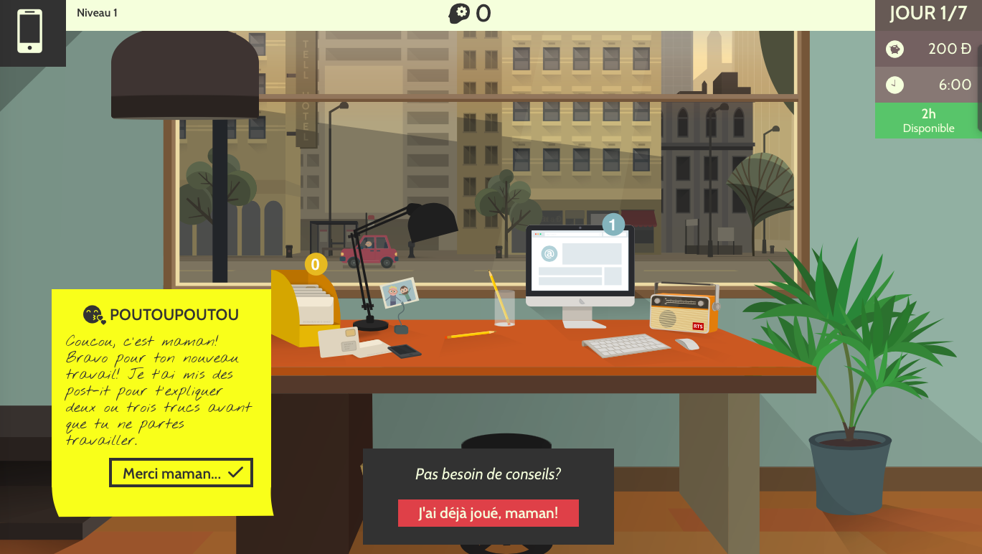
The aim is to raise awareness of data collection in all areas of life and how that data is used, without resorting to do-goodism and pessimism. Issues are therefore addressed in a way that is informative – giving players the option of accessing the results of the RTS investigation and various practical advice – as well as fun, through games and videos by comedians and YouTubers. The use of different formats (e.g. games, radio interviews, video reports, written articles) familiarises students with different media and allows them to compare the impact of the messages they contain.

SUBJECTs AND objectives

MITIC and IT

Understand new information and communication technologies as a social and economic phenomenon.

Consider the ethical aspects of disclosing and processing information.

Gauge the importance and impact of information technologies in daily life.

Social sciences

Think about their status as an individual in a community; become aware of their responsibilities as an individual.

Engage with issues of a moral or social character.

Economics and law

Consider how the legal environment and economic activity complement each other.

Languages

Gradually acquire language skills in context in the different communication activities: production (written and oral), comprehension (written and oral) and interaction.

Use the complementary resources available in the target language: media, audiovisual documents, internet.

AREAS TO EXPLORE
ACTIVITY 1:
BIG DATA
(lesson 1)

What is it?
- Initiate the discussion: have pupils ever disclosed any of their personal data online? In the table, list the services that collect our data.
Possible answers: social media, email accounts, debit cards, loyalty cards, travel cards, health insurance, CCTV systems, etc.

- Classify the answers given into broad categories.
Possible answers: the internet in daily life/social media/public institutions/commerce/health

- Hand out Pupil answer sheet 1 and get pupils to complete it. Pool the answers to determine which data we disclose most often.
Possible answers: email, identity information (surname, first name, date of birth), address and geographic location, search history in search engines, purchasing preferences, etc.

Questions on big data
- Initiate a debate: for what purpose is our personal information collected? Do pupils feel adequately informed on the subject? Is it possible for users to access their data once it has been passed on?

- Listen to an RTS report to get the discussion going. Highlight the type of data passed on, the purpose of data collection, the possible dangers, and ways of accessing data.

- Lower secondary: Que reste-t-il des métadonnées des photos après publication sur le net?(What remains of photo metadata after photos are published online?) (7 min.)
- Upper secondary: Le wifi est le moyen le plus facile pour vous traquer (Wi-Fi- the easiest way to track you) (14 min.)

Datak – the game about big data
- Introduce the game: pupils assume the role of a trainee hired to help the mayor of DataVille with data management. The traineeship lasts seven days but the trainee can be sent home at any time if he or she fails to manage the available time and budget. As in real life, we can’t always do the right thing, so we have to make choices to stay as true as possible to our ideals while respecting certain constraints… In his or her private life, the trainee also receives emails, post and SMS soliciting their personal data.

- Split the class into groups (choose pseudonyms that are easy to adapt for the rankings at the end of the game, e.g. nameofschool_1, nameofschool_2, etc.)
- Lower secondary: playing in teams will help students progress in the game. Define how decisions are to be made to solve the dilemmas, e.g. discussions to reach a consensus, taking turns to make decisions.
- Upper secondary: split the class in half and get one group to play the game individually while the others listen to an RTS report. For example: Santé numérique : un trafic lucratif! (Digital health: lucrative traffic) (29 min.); Décocher le partage de données ne sert à rien, WhatsApp livre tout à Facebook ! (No point deselecting data sharing, Whatsapp passes everything on to Facebook anyway) (7 min.).

- Organise information collection
In the course of the game, each team uses Pupil answer sheet 2 to compile as much information as possible on a service that carries out data collection: email service, loyalty card, travel card, CCTV, etc. This filled-out document will be very useful for activity 3 (review).

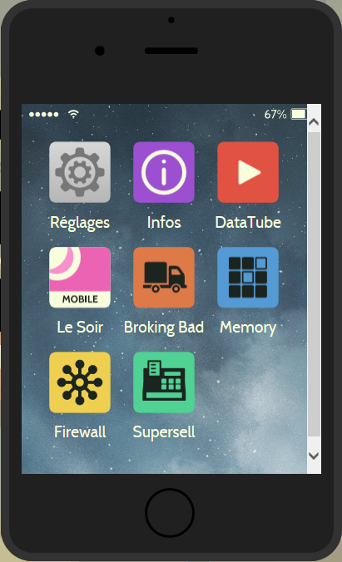
ACTIVITY 2:
STARTING THE GAME
(2 lessons)

First round with no teacher intervention
(this round can be short: pupils are unaware of the intricacies of the games and have little information about data collection). To access the game > www.rts.ch/datak

Initial assessment
  - What difficulties did pupils encounter during the game?
Possible answers: consulting many different information channels (SMS, email, post, newspaper, newsletter, files…); avoiding delays which are heavily penalised; solving dilemmas when you don’t know much about the subject and weighing up the legal and moral aspects; ensuring enough money to continue the game; etc.

  - How can you improve your score?
Possible answers: take into account the decisive criteria – time, salary and mayor’s expectations; change certain behaviour (particularly with regard to promotional offers) and build your knowledge (by taking the time to read up and find out).

  - Conclude by focusing on the link between the game and real life: the preoccupations that guide players, for example time management, are the same as those in an ordinary citizen’s daily life.

Second and third rounds
  - Start the second round and review progress: have pupils’ scores improved?

  - List the general information collected by players
Possible answers: free services in exchange for data (“when it’s free, it means you’re the product”); the information collected is said to be anonymous but it is linked to the IMEI number of your phone, and therefore to the person using it; data is mainly used for commercial purposes, but sometimes in the interest of the community; anyone can request access to their personal data; there are rules governing data collection.

  - For the third round, suggest that players adopt different behaviour: some should try to improve their score (and therefore obtain as much information as possible in the game); others should choose to freely disclose their own and DataVille’s data; the third should ensure maximum security for their data.
Analyse the paths taken in the game. What happens, for example, if you refuse to install CCTV cameras? Why?
Possible answer: the mayor decided to install CCTV cameras against the trainee’s advice. In this way, too, the game reflects real life – there are thought to be between 100,000 and 150,000 CCTV cameras in Switzerland – to help internet users make informed decisions in their own lives.

ACTIVITY 3:
REVIEW
(1 lesson)

Sharing answers on pupil answer sheet 2
  - What loopholes and dangers of mass data collection were identified?

Possible answers:

Commercial and security interests are opposed to individual liberties

Data is not sufficiently secure (piracy, servers based abroad…)

Necessity and inadequacy of the legislative framework and/or monitoring/sanctions

Poor information policy on the part of public institutions (in the case of CCTV) and private companies (illegible terms and conditions)

Difficulty in accessing, or deleting, your data once it has been passed on.

Are there any benefits? If so, which ones?
Possible answers: improved traffic flow, medical advances, targeted health warnings, receiving relevant offers, etc.

Emphasise the legal issues: which laws apply to data collection?

Possible answers:

Rules on the electoral register or similar computer files

Ban on compulsory insurance adapting its rates on the basis of client data

Ban on transport companies and municipal authorities preserving and analysing data obtained through travel cards

Rules on the installation of surveillance cameras in public places

Option for everyone to request their personal data (Art. 8 FADP),

Revision under way of the Federal Data Protection Act and new European law.

Etc.

- Upper secondary:
- Ask pupils about compliance with this legal framework, taking as an example the debate about SwissPass inspection data. After listening to the RTS report (8 mins), explain that the SBB had to delete the information collected from passengers holding a SwissPass.
- Take the opportunity to define the role of the Swiss Federal Data Protection Commissioner (there is an explanation in the report CFF et TL ne respectent pas la loi (SBB and TL are breaking the law), 02’23’’ to 03’00’’) and draw a distinction with the powers of the cantonal data protection commissioners.

Case study

What personal data were pupils asked to disclose during the game? Did they do so?

Is there an information notice about the data disclosure?

Possible answer: the information is located in the smartphone under ‘Info’. It is likely that not all players will have thought of looking for it and referring to it.

Why did the game’s creators decide not to collect players’ data?

Possible answer: to raise pupils’ awareness of the practices of companies that collect data.

.

Effectiveness of the message

Watch the videos available in the game on the smartphone: identify the speaker and the register used. What role do these videos play?

Possible answer: in a short and punchy format, well-known comedians and YouTubers use humour (irony, self-deprecation, ridicule, visual gags, etc.) to encourage users to protect their data without dramatizing.

Videos, games, links to articles and TV or radio reports… Are pupils more sensitive to certain resources? Which ones? Does combining them ensure the message is diffused more effectively and above all better understood?

Conclusion: at the end of the game, do pupils feel they are better informed?

POSSIBLE EXTENSIONS

- Escaping big data

While listening to the programme Les bonnes pratiques numériques pour protéger sa vie privée (Good digital practices to protect your privacy) (8’58’’ to 15’18’’), list some simple steps that you could take to secure your data: using search engines that don’t track their users (https://duckduckgo.com), opt for a Swiss email provider, set up a ‘trash’ email address, change browser…

Based on the #mesdonnees survival guide offered by RTS, try experimenting.
Examples:
    - Lower secondary: test an alternative to Whatsapp (threema.ch, bbm.com, telegram.org). What do pupils think of it?
    - Upper secondary: listen to an excerpt from the report Google nous répond enfin (Google finally replies) (from the beginning to around 03’40’’) and organise a session in which pupils modify their privacy settings to prevent the collection of certain data from their account.

- Requesting your personal data

- As the investigation on which the game is based was interactive, pupils can now request their own data, for example from the school or from their mobile operator. After listening to témoignage du juriste Max Schrems (the account from lawyer Max Schrems) (08’20’ to 9.35’’), they can use the sample letters to exercise their rights.

EXTRA RESOURCES

- A dossier from newspaper Le Monde which provides access to many articles (French only): Le big data va-t-il changer nos vi(ll)es? (Will big data change our lives and our cities?)
- A dossier from Arte (French only): Big Data, opportunité ou dangers ?(Big data: opportunity or risk?)
- Article from La Tribune de Genève (09.05.16) (French only): La médecine du « Big Data » n'est pas sans danger (Big data in healthcare is not without its dangers)
- The RTSdécouverte dossier (French only): http://www.rts.ch/decouverte/sciences-et-environnement/technologies/protection-des-donnees/
- Interactive web documentary supported by Arte do not track (French only): https://donottrack-doc.com/fr/
- The website of the Federal Data Protection and Information Commissioner: https://www.edoeb.admin.ch/index.html?lang=en

Cécile Desbois-Müller, educational content writer, May 2017.
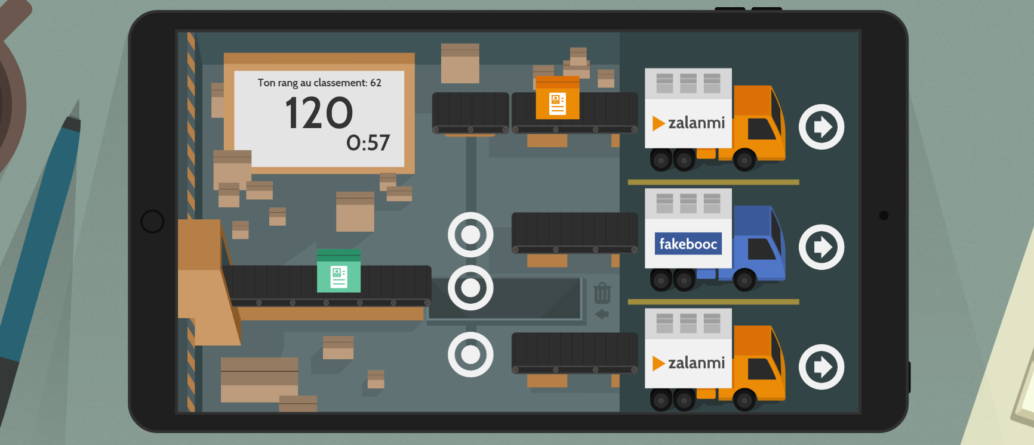

PUPIL ANSWER SHEET 1: MY PERSONAL DATA
Indicate the data that you think you have supplied to the different services, and then think about why the services in question are interested in your data.

 | Service | Data collected | Utility for the services
Internet in daily life | Email
 | Web browser
 | Others:
Social media | Facebook, Whatsapp or other service
Commerce | Loyalty cards (e.g.: Fnac, Migros, etc.)
 | Debit cards
 | Travel cards
Institutions | School
 | Municipal services
Health insurance | Medical records
 | Others?

PUPIL ANSWER SHEET 2: WHAT YOU NEED TO KNOW ABOUT…
(Complete the title with the name of the subject studied, e.g. CCTV, web browsers)

Information
Purpose of the data collection (tracking, sale of advertising space, etc.)

Information policy regarding data collection (is the user informed? How?)
Rules or legislation governing data collection

Possibility of accessing your data (and potentially deleting it) after you have handed it over
Dangers of this data collection

Interest for society and individuals

How can you avoid handing over this type of data?

